**ENHANCING THE CUSTOMER CHURN PREDECTION FOR TELECOM CHURN**

1. **Introduction for telecom churm**

**1.1 OVERVIEW**

Telecom churn refers to the phenomenon of customers switching from one telecom service provider to another. This is a common occurrence in the telecommunications industry, where customers are often presented with a wide range of options to choose from, including different pricing plans, service quality, network coverage, and customer support.

Churn is a critical metric for telecom companies, as it can have a significant impact on their revenue and profitability. High churn rates can lead to a loss of customers, which can, in turn, result in a decline in revenue and market share. Therefore, telecom companies invest heavily in retaining their customers by providing superior service quality, competitive pricing, and attractive loyalty programs.

Analyzing churn patterns can also provide valuable insights into customer behavior, which can be used to improve customer retention strategies, optimize pricing plans, and enhance customer experience. To this end, telecom companies often use advanced analytics and machine learning algorithms to predict customer churn and take proactive measures to reduce it.

**1.2PURPOSE**:

Telecom companies are interested in reducing churn because it is more expensive to acquire new customers than to retain existing ones. Additionally, loyal customers tend to be more profitable than new ones, as they are more likely to upgrade their service plans and purchase additional services over time. By reducing churn, telecom companies can increase their revenue, improve customer satisfaction, and strengthen their market position.

**2. PROBLEM DEFENATION& DESIGN THINKING**

**2.1 EMPATHY MAP**

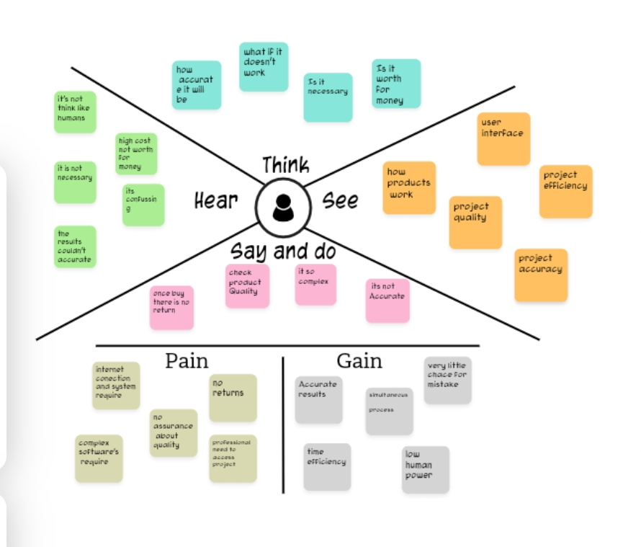

**2.2 IDEATION & BRAINSTORMING MAP**

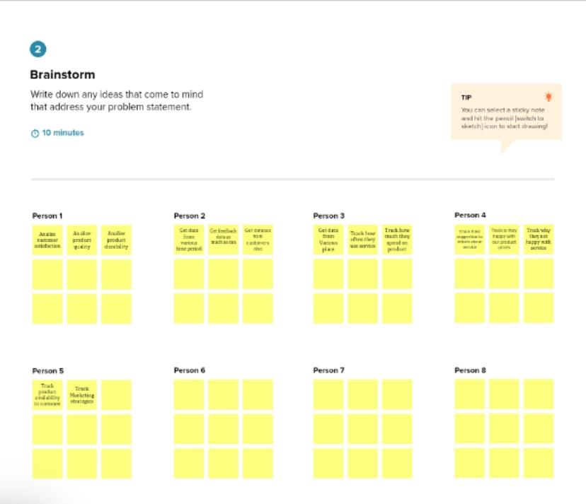

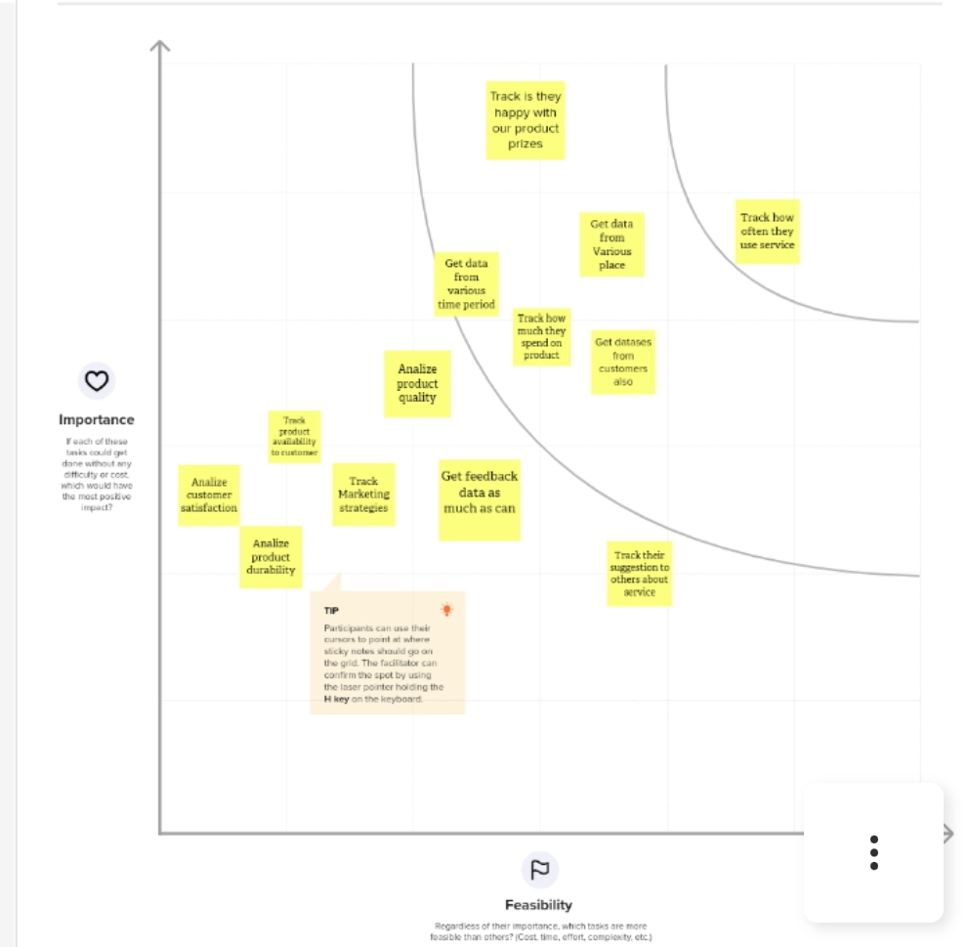

**3. RESULT:**

**Telecom churn reduction.**

**Purpose of telecom churn**

Telecom churn refers to the phenomenon where customers of a telecom service provider switch to a different provider or stop using the service altogether. The purpose of studying telecom churn is to understand why customers leave and to develop strategies to reduce the rate of customer defection. Telecom companies are interested in reducing churn because it is more expensive to acquire new customers than to retain existing ones. Additionally, loyal customers tend to be more profitable than new ones, as they are more likely to upgrade their service plans and purchase additional services over time. By reducing churn, telecom companies can increase their revenue, improve customer satisfaction, and strengthen their market position.

**4. ADVANTAGE AND DISADVANTAGES**

**4.1 Advantages of a telecom churn machine learning project:**

Accurate predictions: Machine learning algorithms can analyze large amounts of data to identify patterns and predict customer churn with high accuracy.

Cost-effective: By identifying customers who are likely to churn, telecom companies can take proactive measures to retain them, which can be more cost-effective than acquiring new customers.

Customer satisfaction: By using machine learning to analyze customer data, telecom companies can identify areas where customer satisfaction is low and take action to improve the customer experience.

Competitive advantage: Companies that are successful in reducing churn can gain a competitive advantage by retaining more customers than their competitors.

**4.2 Disadvantages of a telecom churn machine learning project:**

Data quality: Machine learning algorithms require high-quality data to generate accurate predictions. If the data is incomplete or inaccurate, the predictions may be unreliable.

Complexity: Machine learning algorithms can be complex and require expertise to develop and implement. Companies may need to invest in training or hiring data scientists or machine learning experts.

Privacy concerns: Collecting and analyzing customer data can raise privacy concerns, and companies must ensure that they are complying with relevant privacy regulations.

Cost: Developing and implementing a machine learning project can be expensive, and the benefits may not outweigh the costs for smaller telecom companies.

**5. THE APPLICATIONS OF DELICOM:**

**The application of telecom churn machine learning projects can be used in the following ways:**

most likely to churn and take proactive measures to retain them. This can include offering incentives, improving the Customer retention: Telecom companies can use machine learning algorithms to predict which customers are customer experience, or upgrading the customer's service plan.

Product development: Machine learning algorithms can analyze customer data to identify areas where the company can improve its products or services, which can lead to increased customer satisfaction and reduced churn.

Targeted marketing: Machine learning algorithms can analyze customer data to identify patterns and preferences, allowing the company to target its marketing efforts more effectively. This can result in higher conversion rates and reduced churn.

Network optimization: Machine learning algorithms can analyze network data to identify areas where network performance can be improved, which can improve the customer experience and reduce churn.

Fraud detection: Machine learning algorithms can analyze usage patterns to detect fraudulent activity, which can reduce revenue losses and improve customer satisfaction.

Overall, the application of telecom churn machine learning projects can help telecom companies to reduce churn, increase customer satisfaction, and improve their bottom line.

**6. Conclusion :**

Customer churn is the most important particle when we trying to retain the customers. Because it's important to know that how many of your customers are happy with your project. Our project is based on enhancing the Customer churn predicted on telecom, Because getting a accurate value on churn is more important because the steps you make to retain your Customers are based on the Churn value. In our project we try to create the accurate churn value as much as possible

**7. Future Scope:**We all know about Competition on telecom field. Because of this high level Competition they should create many plans as much as possible to create these plans we really want to know about the telecom churn value to make better and efficient plans cost-effectively

**8.APPENDIX**

